

CS5481 Data Engineering
Assignment 1

- College: College of Computing
- Major: Computer Science
- Student Name: CHEN Xian
- Student Number: xxxxxx8

Contents
Question1 – Online Reviews Data Collection 1
1 Code Design and Workflow 1
2 Results Analysis 1
3 Code 2
4 Results 4
Question2 – Data Cleaning with Regular Expressions 5
1 Code Design and Workflow 5
2 Results Analysis 5
3 Code 5
4 Results 8
Question3 – Data Processing 9
1 Code Design and Workflow 9
2 Results Analysis 9
3 Code 9
4 Results 11
Question4 – Data Visualization 12
1 Code Design and Workflow 12
2 Results Analysis 12
3 Code 12
4 Results 4

Question1 – Online Reviews Data Collection
1 Code Design and Workflow
- Initialize Selenium
  - Open Chrome browser and navigate to the IMDb movie review page.
- Load Additional Reviews（the page only displays 25 reviews by default）
  - Locate the "25 More" button.
  - Scroll to the position of it.
  - Click it to load more reviews dynamically.
- Extract Review Data
  - Select the top 30 review elements.
  - For each review, extract:
    - Username
    - Review date
    - Review text
    - Helpful and non-helpful counts
    - Rating score (if exist: sometimes replaced by the user's expression)
- Store Data
  - Save all extracted information in a list of dictionaries.
- Export Data
  - Convert the list into CSV and JSON formats.

2 Results Analysis
- Reviews Collected
  - Successfully collected 30 reviews as required.
- Completeness
  - All reviews include text, user, date, and helpfulness votes; some ratings are missing but handled appropriately.
  - All reviews include username, review date, review text, rating and helpful/non-helpful votes.
  - Some reviews do not have a numeric rating. The short text provided by the user is stored instead.
- Data Quality
  - Textual and numerical data are clean and structured.
  - multimedia elements are ignored.
3 Code
from selenium import webdriver
from selenium.webdriver.common.by import By
from selenium.webdriver.support.ui import WebDriverWait
import pandas as pd
import json
import time

browser = webdriver.Chrome()
browser.get("https://www.imdb.com/title/tt0111161/reviews")
button = browser.find_element(By.CSS_SELECTOR, "button[class='ipc-btn ipc-btn--single-padding ipc-btn--center-align-content ipc-btn--default-height ipc-btn--core-base ipc-btn--theme-base ipc-btn--button-radius ipc-btn--on-accent2 ipc-text-button ipc-see-more__button']")
browser.execute_script('arguments[0].scrollIntoView(false);', button)
time.sleep(1)
button.click()
StoreData = []
amount = 0

time.sleep(2)
reviews = browser.find_elements(By.CSS_SELECTOR, "article.user-review-item")[:30]
for el in reviews:
amount=amount+1
username = el.find_element(By.CSS_SELECTOR, "a[data-testid='author-link']").text
reviewdate = el.find_element(By.CSS_SELECTOR, "li[class='ipc-inline-list__item review-date']").text
reviewtxt = el.find_element(By.CSS_SELECTOR, "h3[class='ipc-title__text ipc-title__text--reduced']").text
reviewhelpfulcount = el.find_element(By.CSS_SELECTOR, "span[class='ipc-voting__label__count ipc-voting__label__count--up']").text
reviewnonhelpfulcount = el.find_element(By.CSS_SELECTOR, "span[class='ipc-voting__label__count ipc-voting__label__count--down']").text
rating = el.find_elements(By.CSS_SELECTOR, "span[class='ipc-rating-star--rating']")
if rating:
rating = rating[0].text + '/(10)'
else:
rating = el.find_element(By.CSS_SELECTOR, "h3[class='ipc-title__text ipc-title__text--reduced']").text

StoreData.append({
"Source": "IMDB",
"UserName": username,
"ReviweDate": reviewdate,
"Reviewtext": reviewtxt,
"Helpfulcount": reviewhelpfulcount,
"Nonhelpfulcount": reviewnonhelpfulcount,
"Rating": rating
})

browser.quit()

filename = 'reviewIMDB.csv'
df = pd.DataFrame(StoreData)
df.to_csv(filename, index=False)

StoreData.append({
"Amount": amount
})
with open("reviewIMDB.json",'w',encoding='utf-8') as json_file:
json.dump(StoreData,json_file,indent = 4, ensure_ascii=False)

4 Results
- CSV
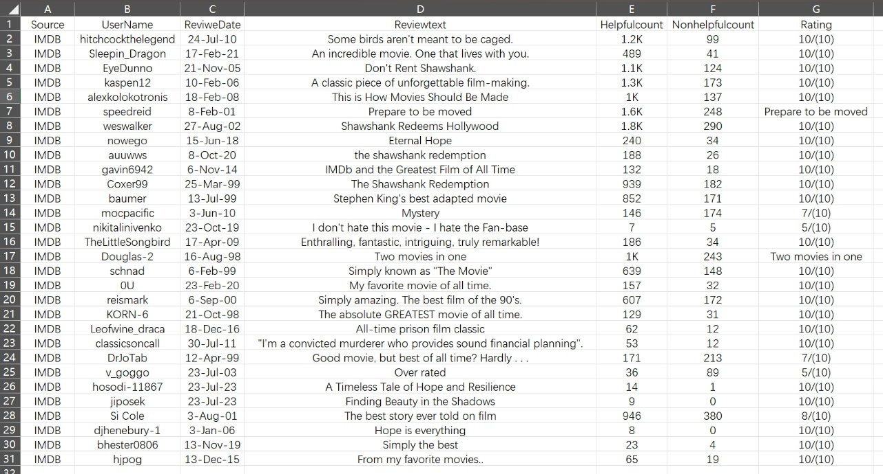
- JSON
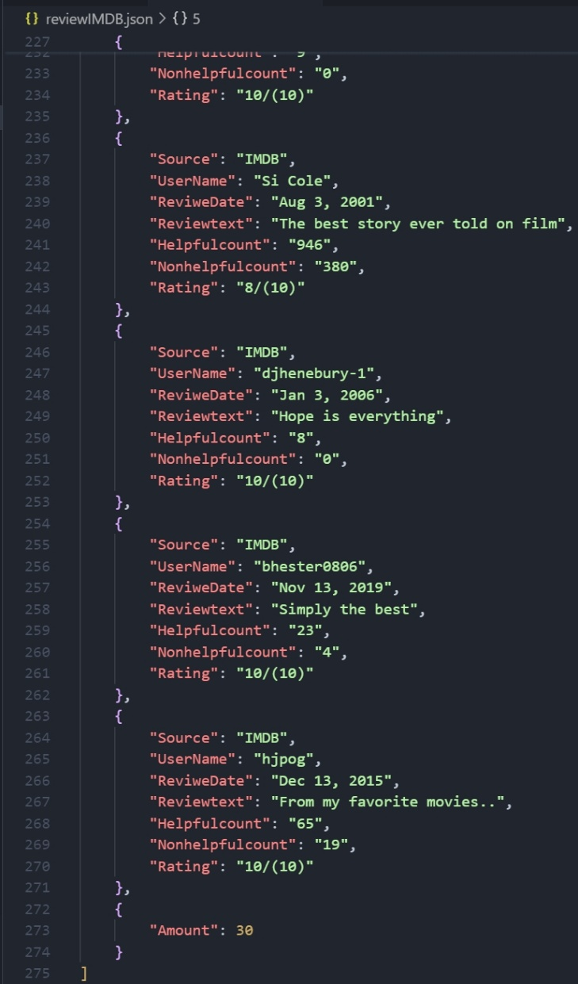
Question2 – Data Cleaning with Regular Expressions
1 Code Design and Workflow
- Importing RE Module
- Task-wise Execution
  - For each task, a dedicated regular expression is defined.
  - A test cases specified in the assignment is defined (test_cases1/2/…).
- Matching
  - Applying the regular expressions to each test string.

2 Results Analysis
- Comprehensive Coverage
  - Successfully implements the corresponding regular expressions for all 10 tasks required by the assignment.
- Accuracy
  - All test results meet expectations.
- Clear Outcome
  - The code structure is clear.
  - The output clearly demonstrates the performance of each regular expression on its respective test cases.

3 Code
import re

print("--- Task 1: Alphabetic Characters Only ---")
REpattern1 = r'^[a-zA-Z]+$'
test_cases1 = ['Python', 'DataScience', 'Hello123']
for text in test_cases1:
if re.fullmatch(REpattern1, text):
print(f"'{text}' -- Contains only alphabetic characters")
else:
print(f"'{text}' -- No Match")
print("-" * 30)
print("--- Task 2: Words Beginning with a Consonant ---")
REpattern2 = r'\b[b-df-hj-np-tv-z]\w*'
test_cases2 = ["cat", "elephant", "dog", "owl"]
for text in test_cases2:
if re.match(REpattern2, text, re.IGNORECASE):
print(f"'{text}' -- A word beginning with a consonant")
else:
print(f"'{text}' -- No Match")
print("-" * 30)
print("--- Task 3: Validate Domain Name ---")
REpattern3 = r'^([a-zA-Z0-9]([a-zA-Z0-9-]*[a-zA-Z0-9])?\.)+[a-zA-Z]{2,}$'
test_cases3 = ['openai.org', 'invalid@site', 'my-site.net']
for text in test_cases3:
if re.fullmatch(REpattern3, text):
print(f"'{text}' -- Validate Domain Name")
else:
print(f"'{text}' -- No Match")
print("-" * 30)

print("--- Task 4: Extract All Integers ---")
REpattern4 = r'\d+'
test_case4 = 'He scored 45 goals in 2022 and 10 goals in 2023.'
numbers = re.findall(REpattern4, test_case4)
print(f"Extracted numbers: {numbers}")
print("-" * 30)

print("--- Task 5: Identify Valid File Paths ---")
REpattern5 = r'^(?:[a-zA-Z]:\\|/)?(?:[\w.-]*[a-zA-Z0-9]+/)*[\w.-]+\.(txt|csv|jpg|doc)$'
test_cases5 = ['/home/user/file.txt', 'report.doc', '/tmp/image.jpg']
for text in test_cases5:
if re.search(REpattern5, text):
print(f"'{text}' -- Valid File Path")
else:
print(f"'{text}' -- No Match")
print("-" * 30)
print("--- Task 6: Validate Canadian Postal Code ---")
REpattern6 = r'^[A-Z]\d[A-Z]\s\d[A-Z]\d$'
test_cases6 = ['K1A 0B1', '123 456']
for test in test_cases6:
if re.fullmatch(REpattern6, test):
print(f"'{test}' -- Valid Canadian Postal Code")
else:
print(f"'{test}' -- No Match")
print("-" * 30)
print("--- Task 7: Same First and Last Character ---")
REpattern7 = r'^(\w).*\1$'
test_cases7 = ['level', 'stats', 'world']
for text in test_cases7:
if re.fullmatch(REpattern7, text):
print(f"'{text}' -- Match")
else:
print(f"'{text}' -- No Match")
print("-" * 30)
print("--- Task 8: Strong Password Validation ---")
REpattern8 = r'^(?=.*[a-z])(?=.*[A-Z])(?=.*\d)(?=.*[@$!%*?&#])[A-Za-z\d@$!%*?&#]{10,}$'
test_cases8 = ['Secure123!', 'weakpass', 'ValidPass#2023']
for text in test_cases8:
if re.fullmatch(REpattern8, text):
print(f"'{text}' -- Match Strong Password Validation")
else:
print(f"'{text}' -- No Match")
print("-" * 30)
print("--- Task 9: Match Date Formats (mm/dd/yyyy or yyyy-mm-dd) ---")
REpattern9 = r'(\d{2}/\d{2}/\d{4}|\d{4}-\d{2}-\d{2})'
test_cases9 = ['07/04/2021', '2022-12-31', '01/01/2024', '2022/12/31', '13-2020', '07-04-21']
for text in test_cases9:
match = re.fullmatch(REpattern9, text)
if match:
print(f"'{text}' -- Match Date Formats")
else:
print(f"'{text}' -- No Match")
print("-" * 30)
print("--- Task 10: Validate IPv6 Address (Simplified) ---")
REpattern10 = r'^([0-9a-fA-F]{1,4}:){7}[0-9a-fA-F]{1,4}$'
test_cases10 = ['2001:0db8:85a3:0000:0000:8a2e:0370:7334', '1234:5678:90ab:cdefghij:0000:0000:0001']
for text in test_cases10:
if re.fullmatch(REpattern10, text):
print(f"'{text}' -- Valid IPv6 Address (Simplified)")
else:
print(f"'{text}' -- No Match")
print("-" * 30)

4 Results
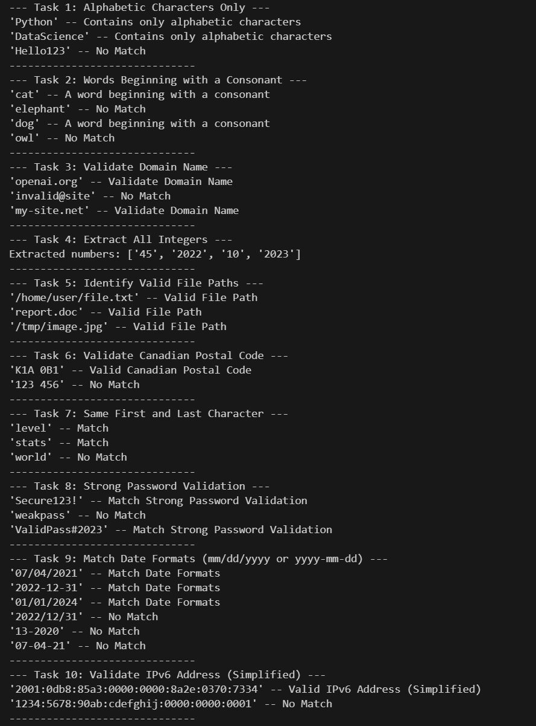

Question3 – Data Processing
1 Code Design and Workflow
- XML to Line-Based TXT
  - XML Parsing[xml.etree.ElementTree module is used to parse the XML content].
  - Text Extraction[The XML tree is traversed to locate and extract all text contained within ‘seg’ tag].
  - Text Cleaning.
    - Convert all text to lowercase using the .lower() method.
    - Remove all punctuation using string.punctuation and str.translate(), then use re.sub() to clean up extra spaces.
  - Saving Results
- BPE Vocabulary Creation
  - Tool Preparation.
  - learn_bpe.py Execution.
    - Set the number of BPE merge operations.
    - Set the standard output to the vocabulary.bpe file.

2 Results Analysis
- XML Conversion
  - Successfully converts structured XML data into line-based text. All tags are removed, and the text is converted to lowercase without punctuation.
- BPE Vocabulary Generation
  - Successfully generates a BPE vocabulary from the cleaned text.

3 Code
import xml.etree.ElementTree as ET
import re
import string

XmlFile = 'Q3/samplehyp.xml'
LineBased = 'Q3/Line-Based.txt'
tree = ET.parse(XmlFile)
root = tree.getroot()

CleanedLines = []
for seg in root.findall('.//seg'):
if seg.text:
text = seg.text
text = text.lower()
text = text.translate(str.maketrans('', '', string.punctuation))
text = re.sub(r'\s+', ' ', text).strip()
if text:
CleanedLines.append(text)

with open(LineBased, 'w', encoding='utf-8') as f:
for line in CleanedLines:
f.write(line + '\n')

#Shell commands to create BPE vocabulary
git clone https://github.com/rsennrich/subword-nmt.git
python subword-nmt/subword_nmt/learn_bpe.py -s 2000 < Line-Based.txt > vocabulary.bpe

4 Results
- Line-Based.txt
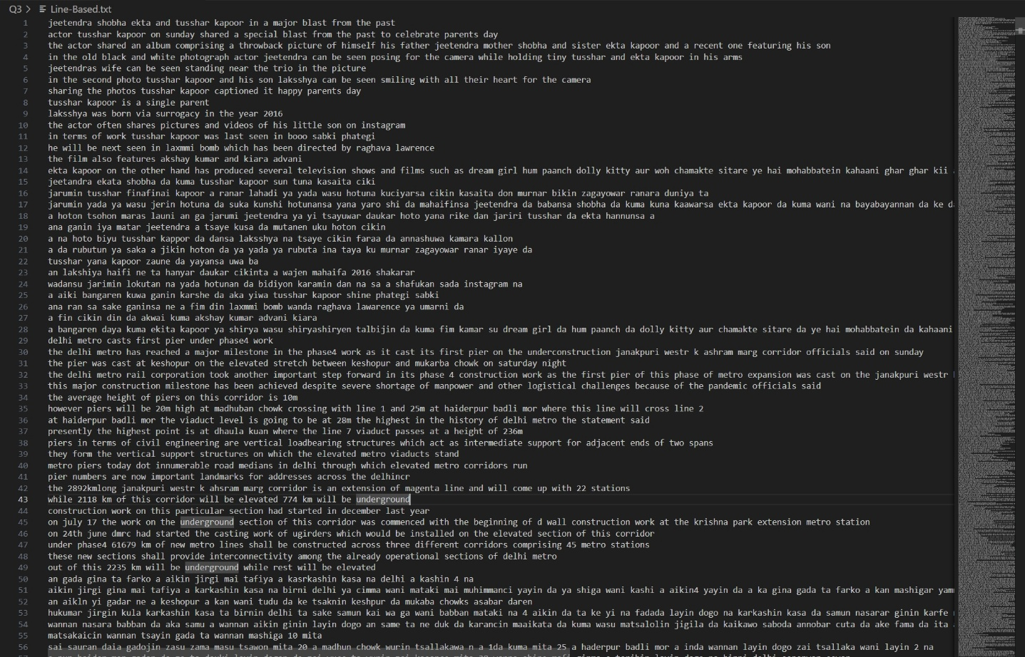
- vocabulary.bpe
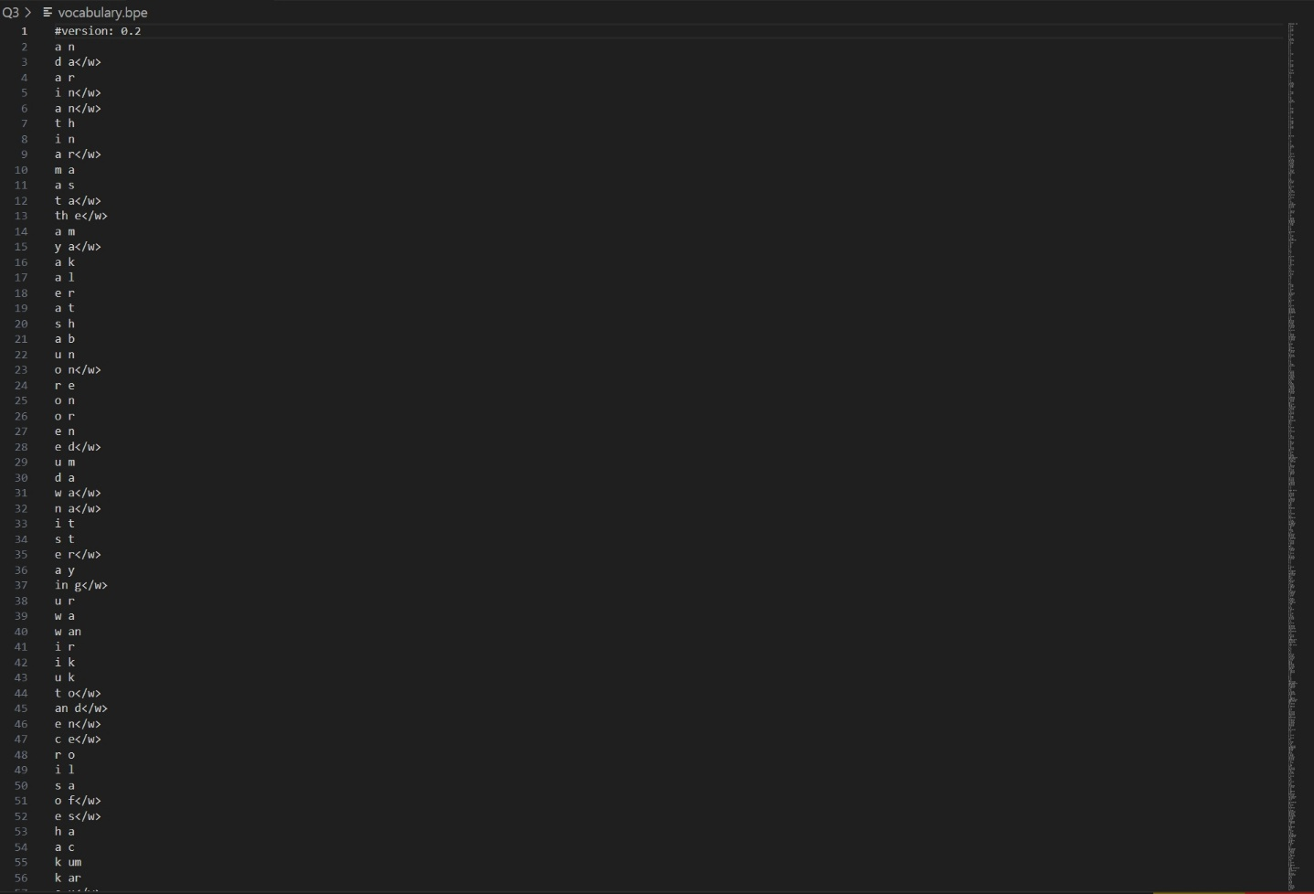
Question4 – Data Visualization
1 Appropriate Visualization Methods (Answer to Q4--->1)
- Explore the distribution of each attribute
  - Major/Gender(categorical variable)[Bar charts or pie charts].
  - GPA (continuous variable)[Histograms].
- Explore the distribution of relationships between attributes
  - GPA vs. Major/ GPA vs. Gender (continuous vs. categorical)[Grouped box plots].
  - Major vs. Gender(categorical vs. categorical)[ Grouped bar chart or Scatter Plot or Heatmap ].

2 Code Design and Workflow
- Importing libraries
  - pandas
  - numpy
  - matplotlib.pyplot
  - seaborn
- Generating student data
  - Create 500 records[use my real studentId ’ 59790558’ as random seed].
  - Student ID:Integers from 1 to 500.
  - Major: Randomly chosen from 'Computer Science', 'Mathematics', 'Physics'.
  - Gender: Randomly chosen from 'Male' and 'Female'.
  - GPA: Random numbers generated from a normal distribution within the range 0.0–4.0.
- Visualization[Q4-3&4]
  - Use seaborn.countplot to create bar charts showing the number of students per major and per gender.
  - Use seaborn.histplot to create a histogram showing the overall distribution of GPA.
  - Use seaborn.boxplot to create grouped box plots to compare GPA distributions across majors and genders.
  - All charts include titles and labels for better readability and are saved as PNG images.

3 Results Analysis
- Comprehensive Coverage
  - Successfully implements the corresponding regular expressions for all 10 tasks required by the assignment.
- Accuracy
  - All test results meet expectations.
- Clear Outcome
  - The code structure is clear.
  - The output clearly demonstrates the performance of each regular expression on its respective test cases.

4 Code
import re

print("--- Task 1: Alphabetic Characters Only ---")
REpattern1 = r'^[a-zA-Z]+$'
test_cases1 = ['Python', 'DataScience', 'Hello123']
for text in test_cases1:
if re.fullmatch(REpattern1, text):
print(f"'{text}' -- Contains only alphabetic characters")
else:
print(f"'{text}' -- No Match")
print("-" * 30)
print("--- Task 2: Words Beginning with a Consonant ---")
REpattern2 = r'\b[b-df-hj-np-tv-z]\w*'
test_cases2 = ["cat", "elephant", "dog", "owl"]
for text in test_cases2:
if re.match(REpattern2, text, re.IGNORECASE):
print(f"'{text}' -- A word beginning with a consonant")
else:
print(f"'{text}' -- No Match")
print("-" * 30)
print("--- Task 3: Validate Domain Name ---")
REpattern3 = r'^([a-zA-Z0-9]([a-zA-Z0-9-]*[a-zA-Z0-9])?\.)+[a-zA-Z]{2,}$'
test_cases3 = ['openai.org', 'invalid@site', 'my-site.net']
for text in test_cases3:
if re.fullmatch(REpattern3, text):
print(f"'{text}' -- Validate Domain Name")
else:
print(f"'{text}' -- No Match")
print("-" * 30)

print("--- Task 4: Extract All Integers ---")
REpattern4 = r'\d+'
test_case4 = 'He scored 45 goals in 2022 and 10 goals in 2023.'
numbers = re.findall(REpattern4, test_case4)
print(f"Extracted numbers: {numbers}")
print("-" * 30)

print("--- Task 5: Identify Valid File Paths ---")
REpattern5 = r'^(?:[a-zA-Z]:\\|/)?(?:[\w.-]*[a-zA-Z0-9]+/)*[\w.-]+\.(txt|csv|jpg|doc)$'
test_cases5 = ['/home/user/file.txt', 'report.doc', '/tmp/image.jpg']
for text in test_cases5:
if re.search(REpattern5, text):
print(f"'{text}' -- Valid File Path")
else:
print(f"'{text}' -- No Match")
print("-" * 30)
print("--- Task 6: Validate Canadian Postal Code ---")
REpattern6 = r'^[A-Z]\d[A-Z]\s\d[A-Z]\d$'
test_cases6 = ['K1A 0B1', '123 456']
for test in test_cases6:
if re.fullmatch(REpattern6, test):
print(f"'{test}' -- Valid Canadian Postal Code")
else:
print(f"'{test}' -- No Match")
print("-" * 30)
print("--- Task 7: Same First and Last Character ---")
REpattern7 = r'^(\w).*\1$'
test_cases7 = ['level', 'stats', 'world']
for text in test_cases7:
if re.fullmatch(REpattern7, text):
print(f"'{text}' -- Match")
else:
print(f"'{text}' -- No Match")
print("-" * 30)
print("--- Task 8: Strong Password Validation ---")
REpattern8 = r'^(?=.*[a-z])(?=.*[A-Z])(?=.*\d)(?=.*[@$!%*?&#])[A-Za-z\d@$!%*?&#]{10,}$'
test_cases8 = ['Secure123!', 'weakpass', 'ValidPass#2023']
for text in test_cases8:
if re.fullmatch(REpattern8, text):
print(f"'{text}' -- Match Strong Password Validation")
else:
print(f"'{text}' -- No Match")
print("-" * 30)
print("--- Task 9: Match Date Formats (mm/dd/yyyy or yyyy-mm-dd) ---")
REpattern9 = r'(\d{2}/\d{2}/\d{4}|\d{4}-\d{2}-\d{2})'
test_cases9 = ['07/04/2021', '2022-12-31', '01/01/2024', '2022/12/31', '13-2020', '07-04-21']
for text in test_cases9:
match = re.fullmatch(REpattern9, text)
if match:
print(f"'{text}' -- Match Date Formats")
else:
print(f"'{text}' -- No Match")
print("-" * 30)
print("--- Task 10: Validate IPv6 Address (Simplified) ---")
REpattern10 = r'^([0-9a-fA-F]{1,4}:){7}[0-9a-fA-F]{1,4}$'
test_cases10 = ['2001:0db8:85a3:0000:0000:8a2e:0370:7334', '1234:5678:90ab:cdefghij:0000:0000:0001']
for text in test_cases10:
if re.fullmatch(REpattern10, text):
print(f"'{text}' -- Valid IPv6 Address (Simplified)")
else:
print(f"'{text}' -- No Match")
print("-" * 30)

5 Results

